* Lab 10: Spring Boot Actuators
* Create another **Spring Starter Project** and name it chapter2.bootactuator. This time, select **Web** and **Actuators** under **Ops**. Similar to the chapter2.bootrest project, add a GreeterControllerendpoint with the greet method.
* Start the application as Spring Boot app.
* Point the browser to localhost:8080/actuator. This will open the HAL browser. Then, review the **Links** section.
* A number of links are available under the **Links** section. These are automatically exposed by the Spring Boot actuator:
* 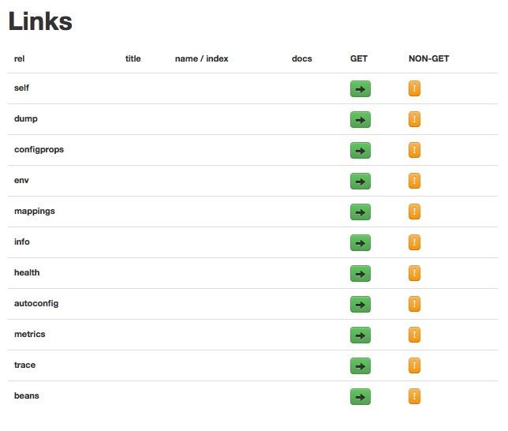

Some of the important links are listed as follows:

* dump: This performs a thread dump and displays the result
* mappings: This lists all the HTTP request mappings
* info: This displays information about the application
* health: This displays the application's health conditions
* autoconfig: This displays the autoconfiguration report
* metrics: This shows different metrics collected from the application